**The First Fujifilm Acuity F printer is at NGS Printing!**

NGS Printing is proud to announce the first installation of the Acuity F in North America. This large format flatbed digital press offers the highest resolution available in the market today. This new purchase, along with the ground breaking purchase on the Inca Onset Q40i last year, keeps with NGS's commitment to using only the best equipment on the market.

The Acuity F is the newest & most productive printer in this popular printer series. It combines 7 years of market leading image quality with leading edge engineering and ink technology to deliver a state-of-the-art platform capable of a wide range of print applications. The Acuity F offers unmatched production speeds for ultra-high quality images. When print quality is very important the Acuity F and its' 7 colors delivers like no other. The addition of the white ink option further extends the application and media range to include clear and colored substrates.

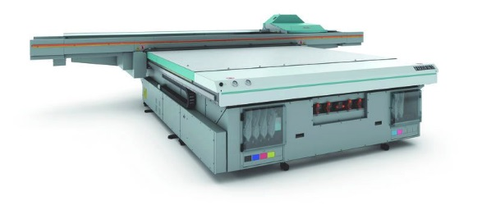

Ask your customer representative for print samples and see the quality difference!

**ATTN DESIGN & PROMOTE:**

**Please attach a link to the Acuity F press release for people to download and print the PDF.**

**Please date this blog post as October 2014**